EXPERIMENT 2 — GAUSSIAN BLUR
Experiment 2 is “Read an image in Python and convert/apply Gaussian Blur.”
AIM
To read an image using Python and OpenCV and apply Gaussian Blur to the given image.
ALGORITHM
- Import the OpenCV library.
- Upload and read the input image.
- Apply Gaussian Blur using cv2.GaussianBlur().
- Display the original image.
- Display the blurred image.
- Save the output image.
PROGRAM
import cv2
from google.colab import files
from google.colab.patches import cv2_imshow

# Upload image
uploaded = files.upload()

# Read image
filename = list(uploaded.keys())[0]
img = cv2.imread(filename)

# Apply Gaussian Blur
blur = cv2.GaussianBlur(img, (15, 15), 0)

# Display original image
print("Original Image:")
cv2_imshow(img)

# Display blurred image
print("Gaussian Blurred Image:")
cv2_imshow(blur)
SAMPLE INPUT
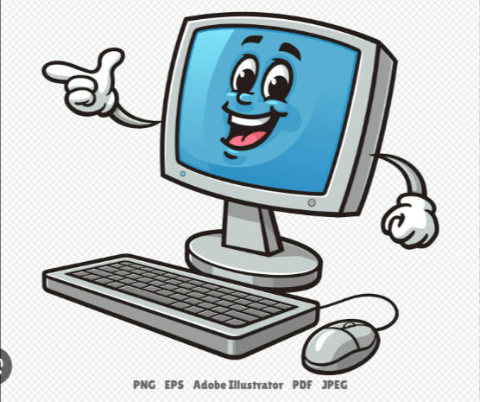
OUTPUT

RESULT
Thus, Gaussian Blur was successfully applied to the given image using Python and OpenCV.

